Site to Site VPN Set up

|  |  |  |  |  |  |
| --- | --- | --- | --- | --- | --- |
| **Device Make & Model** | | Checkpoint R77.30 | | | |
| **Software Version** | | R77.30 | | | |
| **FGH Peer IP Address** | | 81.144.201.76 | | | |
| **IKE Settings – Encryption Scheme:** | 3DES | | Eg. 3DES/AES256/.. | | | | |
| **IKE Settings – D-H Group:** | 2 1024 bit | | Eg. 2 | | | | |
| **IKE Settings – Hashing Algorithm:** | SHA1 | | Eg. SHA1/2.. | | | | |
| **IKE Settings – Authentication Method:** | Pre-Shared Key | |  | | | | |
| **IKE Settings – Pre-Shared Key:** | **** TBA ****  will be advised separately | | |  |  | | |
| **IKE Settings – Regenerate IKE SA every:** | 1440 minutes | | Eg. 86400 SECONDS | | | |
| **IPSec Settings – Encryption Scheme:** | AES-128 | | Eg. 3DES | | | |
| **IPSec Settings – Hashing Algorithm:** | SHA1 | | Eg. SHA | | | |
| **IPSec Settings – Regenerate IPSEC SA every** | 28800 Seconds | | Eg. 8 HOURS | | | |
| **IPSec Settings – PFS enabled** | Yes | | Eg. Yes/No | | | |

Open Checkpoint.

Create new Interoperable device.

Create object with the customers IP address.

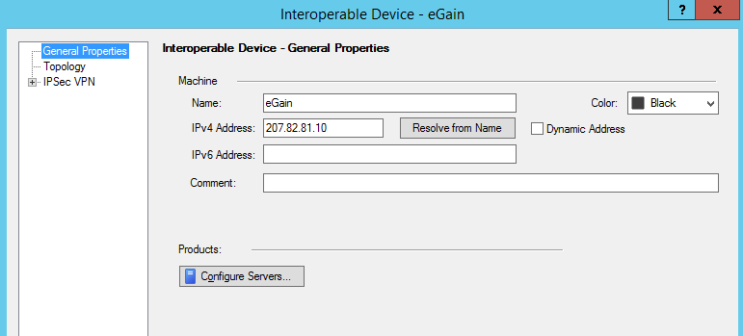

Open IPSec VPN Tab.

Click Communities

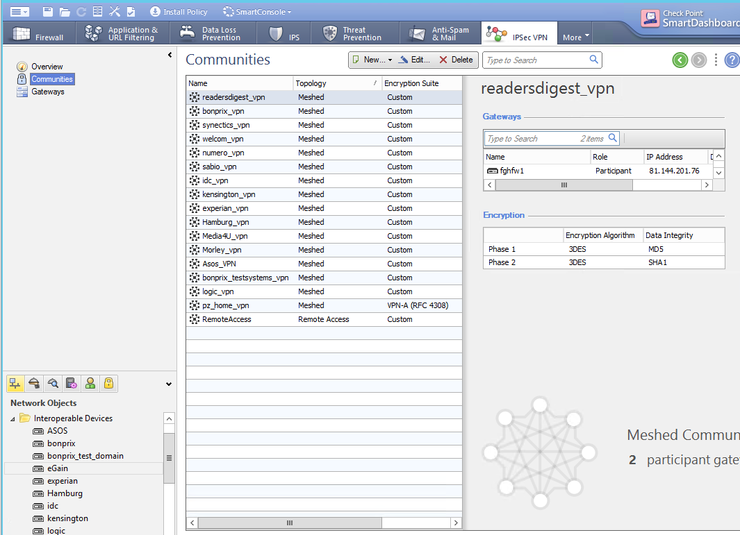

Click New > Meshed Community.

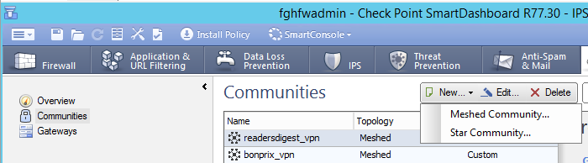

Give it a name.

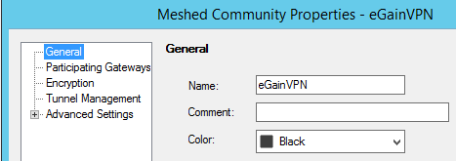

Add the participating Gateways.

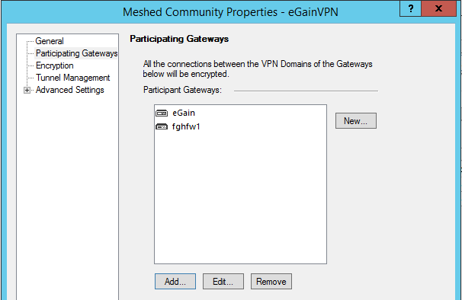

Encryption.

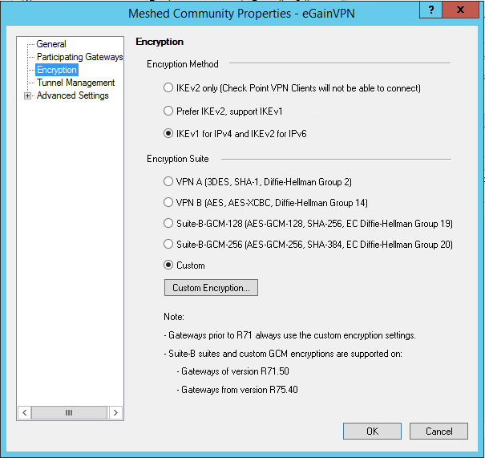

Custom Encryption.

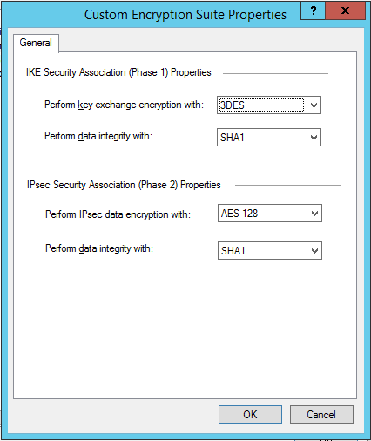

Under Advanced Settings > Advanced VPN Properties, tick Use Perfect Forward Secrecy.

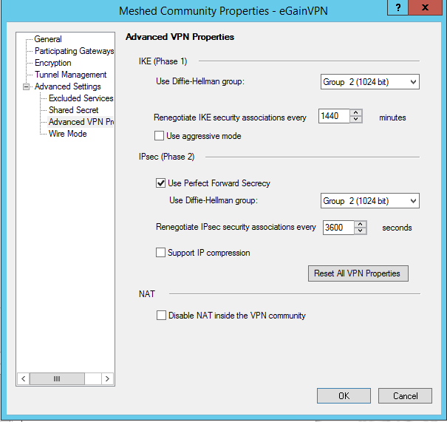

Create Shared Secret.

Sg6yh8gbk9alo9ih3dh2sj7hfg4go9